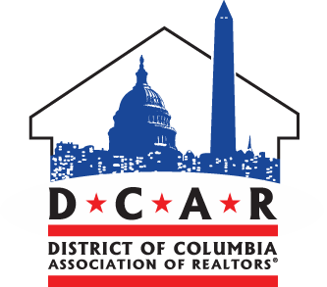
Fiscal Year 2022 Budget Hearing
Committee of the Whole
Council of the District of Columbia
June 25, 2021

Good evening Mr. Chairman, Committee of the Whole, and staff members. Thank you all for allowing me the opportunity to provide comments. My name is Evan Loukadakis, I am the associate director of government affairs for the DC Association of REALTORS® and a Ward 6 resident. DCAR represents over 3,000 members in the District and we are a voice for real estate professionals, small housing providers, homeowners and renters who work and live in Washington.
I think most of you would agree that June 2021 and June 2020 have a striking contrast. Around this time last year, we were reading anxiety-inducing news headlines stating that the pandemic would shatter the budget and that financial circumstances appeared grim.

Today, thanks to the vaccine and COVID relief dollars, we can breathe a sigh of relief. Although our budget is humming to an upbeat tune, it is critically important that the DC Council, as budget appropriators, thoughtfully allocate these funds to meet our communities most pressing needs.

DCAR contends that one of our most important areas to focus on is housing—arguably the most important. The FY 22 Budget reflects priority budget items that we believe will produce, preserve and protect housing in the District.

A marquee housing investment is the historic $400 million contribution to the Housing Production Trust Fund that DCAR was pleased to witness Mayor Bowser announce at Spring Flats in Ward 4. Moreover, we must continue to prioritize homeownership.

While we have made strides in recent years, the District of Columbia ranks last in homeownership at 42.5% compared to other states. DCAR applauds the slated $24.5 million to help low-income, first-time homebuyers with down payments and closing costs assistance and we urge that we continue to strive for more.

Every resident should have access to safe, decent, and affordable housing. DCAR believes a cornerstone of this means to continue working to make homelessness rare and non-recurring. While the District continues to maintain long-term attention on this front—with the Mayor’s proposal to allocate $102million toward temporary shelter renovations—government officials must diligently and compassionately act in the short-term to provide shelter to the thousands of Washingtonians living in tents across the city.

Lastly, with regard to DCRA, we believe this agency has the potential to be a model regulatory agency that political subdivisions across the nation would want to emulate. DCAR recognizes that DCRA has made innovative, noteworthy improvements; however, critical issues persist. We understand that the slated plan is to fund the bifurcation of DCRA into the Department of Buildings and Department of Licensing and Consumer Protection.

Once the transition is complete, DCAR members are available as a resource to help improve systems and processes. Our members interface with core DCRA services day-to-day and have meaningful insight into customer experiences.
In conclusion, we appreciate the commitments made in the budget regarding housing and ask to be included in upcoming conversations on how to sustain the District’s diverse housing needs. As always, our Association members live in all eight wards and are here to answer any questions the Council may have. Thank you all for the opportunity to provide testimony.

